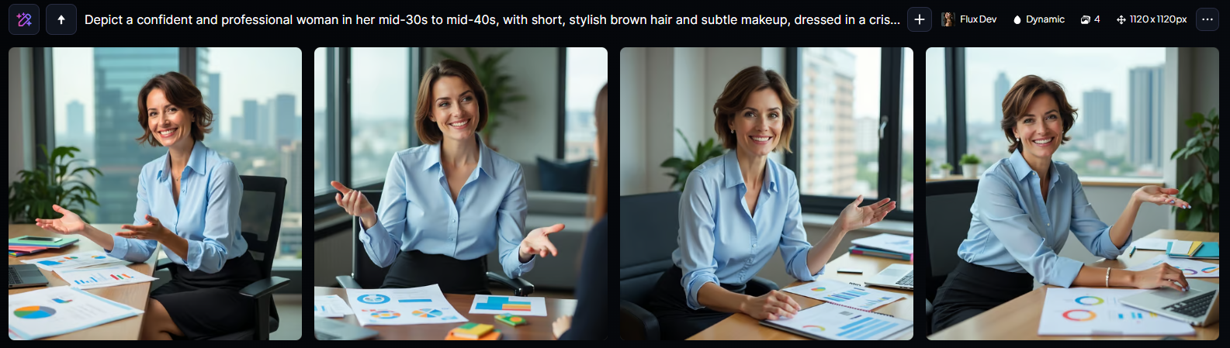

“Depict a confident and professional woman in her mid-30s to mid-40s, with short, stylish brown hair and subtle makeup, dressed in a crisp, light blue blouse and a tailored black pencil skirt, sitting in a modern office with a cityscape view behind her, surrounded by marketing materials such as charts, graphs, and colorful folders, with a laptop and notebooks scattered on a large wooden desk, and a warm, inviting smile on her face, conveying a sense of authority and approachability, with a few strands of hair framing her heart-shaped face, bright brown eyes, and a gentle, rosy complexion, as she gestures with her right hand while explaining a marketing strategy to someone off-camera.”



“Depict a confident and professional woman in her mid-30s to early 40s, likely of European or Mediterranean descent, with curly brown hair styled in a neat bun, bright hazel eyes, and subtle makeup, dressed in a tailored business attire such as a crisp white blouse and a fitted black pencil skirt, standing in a modern corporate office setting with a sleek wooden desk and ergonomic chair behind her, surrounded by scattered papers, laptop, and a few marketing reports, with a warm and approachable smile, conveying a sense of authority and expertise in her role as a Marketing Manager, against a blurred background with a subtle gradient of soft blues and whites, emphasizing her positive and results-driven personality.”



“Depict a confident and ambitious woman in her mid-30s to early 40s, with short, stylishly cut brown hair, subtle makeup, and a warm, approachable smile, dressed in professional attire such as a crisp white blouse, a fitted blazer, and a pencil skirt, standing in a modern office space with a cityscape view in the background, surrounded by marketing materials, laptops, and notes, with a tablet and a cup of coffee on her desk, and a few posters or charts on the wall, showcasing her role as a Marketing Manager, with a sense of elegance, sophistication, and authority.”